JANUARY 2023 LUNCHES

Student __________________________________ Grade ______ Print & Return with Payment $______________ Check #_____________

SUNDAY | MONDAY | TUESDAY | WEDNESDAY | THURSDAY | FRIDAY | SATURDAY
1 | 2  No School  Last Day of Holiday Break | 3  Mini Ham Club,  Chips  Fruit  Milk Only | 4  Chocolate Chip Pancakes, Sausage  Fruit  Milk Only | 5  Chicken w/ Waffles & Gravy, Carrots  Fruit  Milk Only  Milk Only | 6  Pizza  Dessert  Milk Only | 7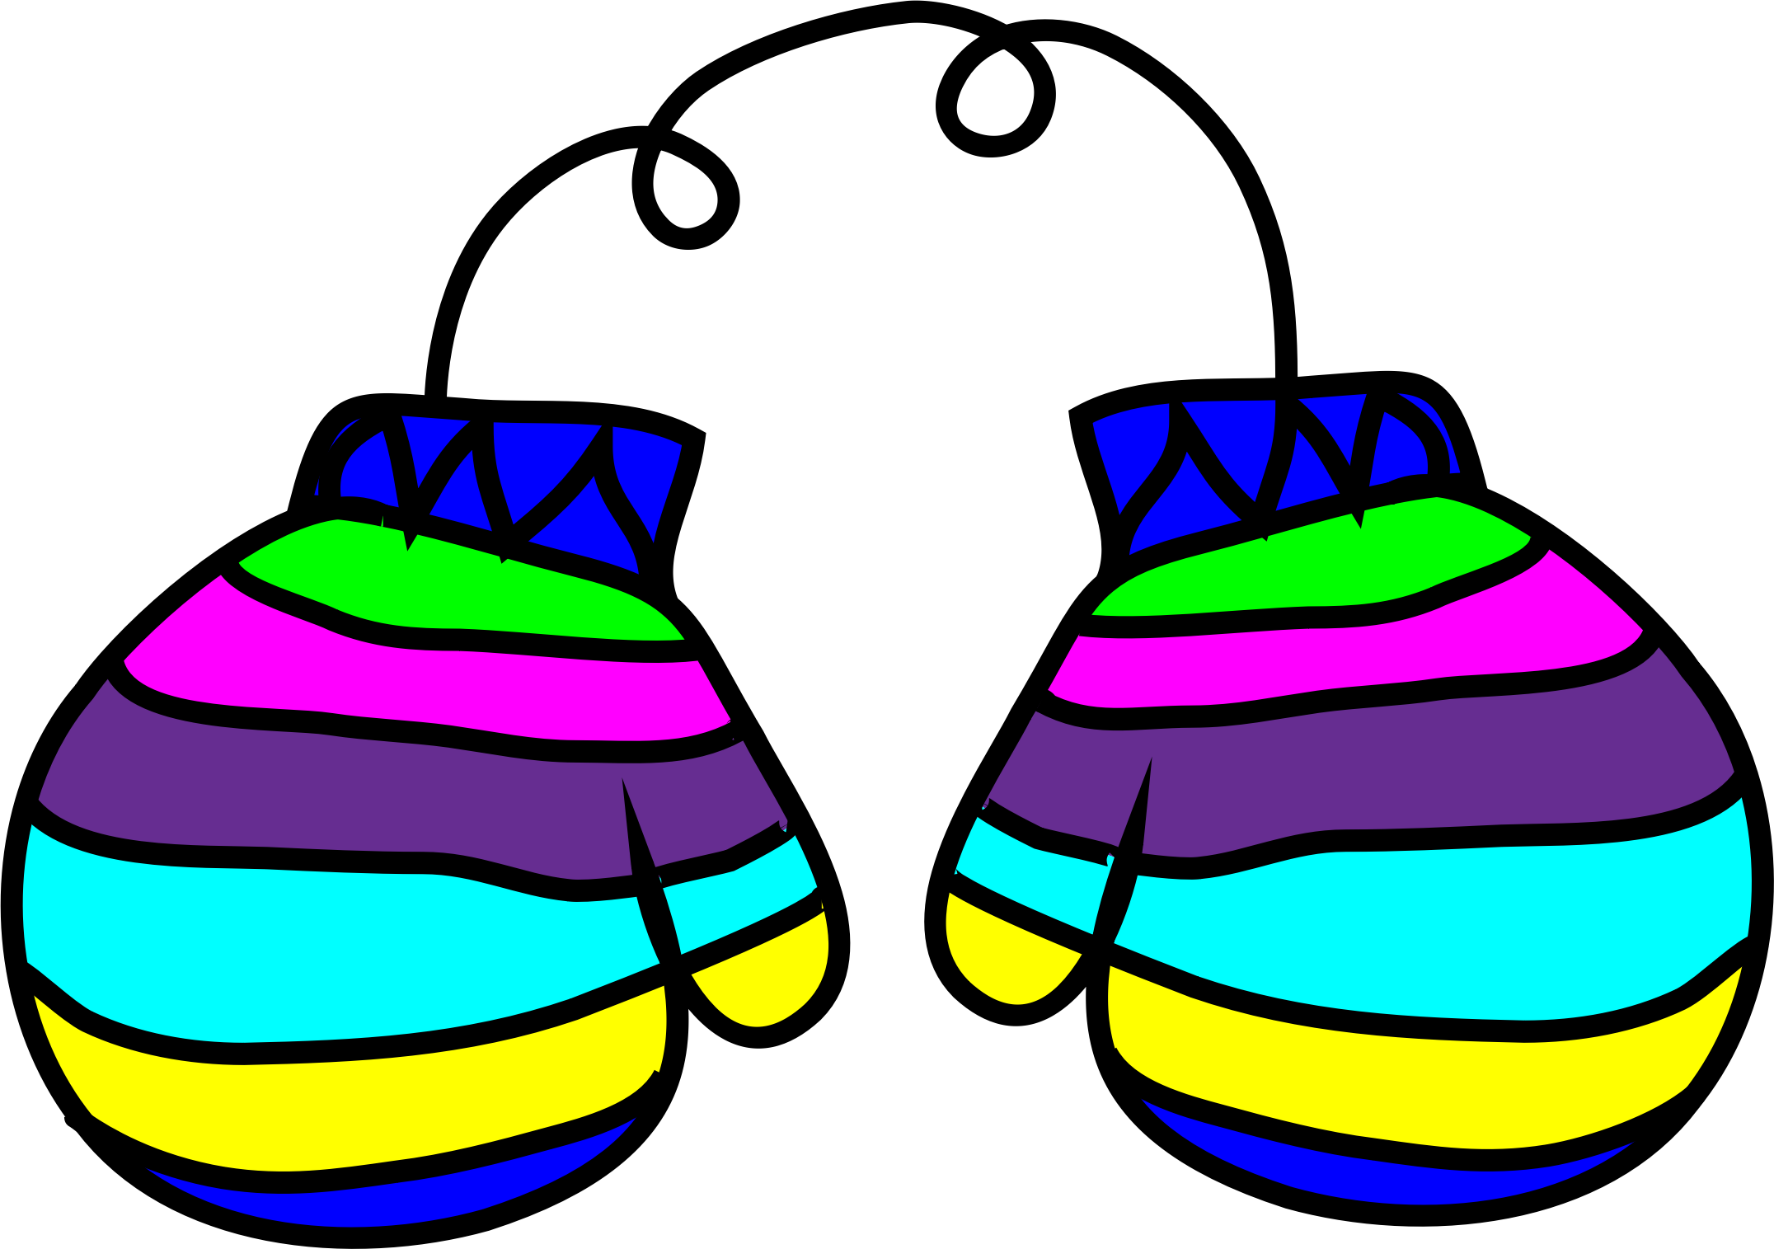
8 | 9  Subway Mondays*  Dessert  T H I  Milk Only | 10 Please Circle One  Cheeseburger Or Hamburger  Tater Tots  Fruit  Milk Only | 11  French Toast,  Ham  Fruit  Milk Only | 12  Beef Bar B Q,  Buttered Noodles  Fruit  Milk Only | 13  Pizza  Dessert  Milk Only | 14
15 | 16 No School  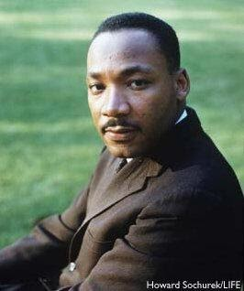r Martin Luther King Jr Day | 17  Chicken Sandwich,  Green Beans  Fruit  Milk Only  Milk Only | 18  Waffles,  Sausage  Fruit  Milk Only | 19  Grilled Cheese,  Tomato Soup  Fruit  Milk Only  Milk Only | 20  Pizza  Dessert  Milk Only | 21
22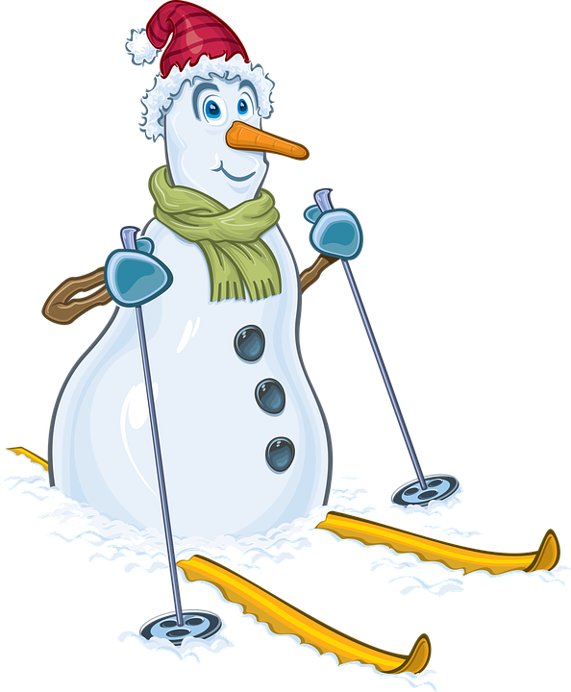 | 23  Subway Mondays*  Dessert  T H I  Milk Only | 24  Meatloaf,  Mashed Potatoes  Fruit  Milk Only | 25  Bacon, Egg, Cheese on English Muffin  Hash Browns  Fruit  Milk Only | 26  Sausage Sandwich w/Sauce,  French Fries  Fruit  Milk Only  Milk Only | 27  Pizza  Dessert  Milk Only |   28

Subway Selections: T= Turkey H= Ham I= Italian Lunches (includes drink): $3.75 each + $2.25 additional entrée/ $.55 Milk Only

