St. John Neumann Regional School SEPTEMBER 2020 LUNCHES

Student ________________________________________ Grade ______ Print & Return with Payment $______________ Check #_____________

SUNDAY | MONDAY | TUESDAY | WEDNESDAY | THURSDAY | FRIDAY | SATURDAY
 | AUG 31  Early Lunch/early dismissal | SEP 1  Packed Lunch  & Drink only this week | 2 | 3 | 4  NO SCHOOL | 5
6 | 7  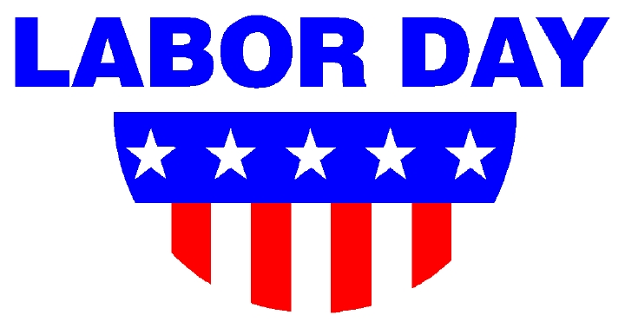 | 8  Hamburger Macaroni  w/Red Sauce  Salad, Roll & Fruit  Milk Only | 9  Sausage, Egg & Cheese on English Muffin, Hashed Brown, Fruit  Milk Only | 10  Chicken Nuggets  Corn  Fruit  Milk Only | 11  Pizza  Dessert  Milk Only | 12
13 | 14  Subway Mondays*  Dessert  T H I  Milk Only | 15  (Circle One)  Hamburger OR  Cheeseburger  Tater Tots & Fruit  Milk Only | 16  Chocolate Chip Waffles  Ham  Fruit  Milk Only | 17  Beef Barbeque  Pierogies  Fruit  Milk Only | 18  Pizza  Dessert  Milk Only | 19
20 | 21  Subway Mondays*  Dessert  T H I  Milk Only | 22  Breaded Chicken Patty  Broccoli & Fruit  Milk Only | 23  Blueberry Pancakes  Bacon  Fruit  Milk Only | 24  Turkey Wrap  Carrot Sticks  Fruit  Milk Only | 25  Pizza  Dessert  Milk Only | 26
27 | 28  Subway Mondays*  Dessert  T H I  Milk Only | 29  Homemade Hamburger Vegetable Soup & Hot Dog  Milk Only | 30  French Toast  Ham  Fruit  Milk Only | OCT 1  Smoked Sausage  Parsley Potatoes  Roll & Fruit  Milk Only  Lunches (includes drink): $3.75 each +$2.25 additional entrée/.55 Milk Only | 2  Pizza  Dessert  Milk Only | 28
*SUBWAY Selections: T = Turkey, H = Ham, I = Italian

