**St. John Neumann Regional School Presents**:

**A family style Spaghetti Dinner**

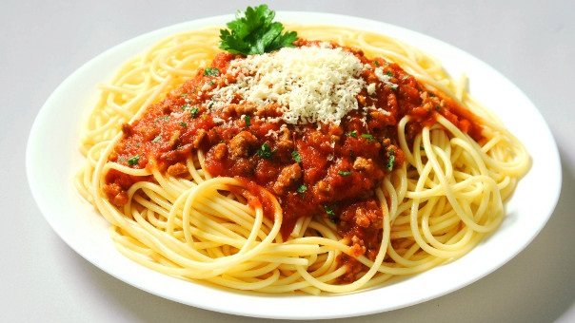

***When****: Saturday October 13th 6-9 pm*

***BYOB***

***Where****: Sacred Heart School Gym, SJNRS*

*259 Lafayette Avenue, Palmerton*

*Come be part of our family and indulge in a variety of homemade sauces created by the families and supporting parishes of SJNRS. Bread, salad, dessert and coffee will also be provided. Take out is available.*

*Tickets will be available at all parishes after masses, or by calling the school at 610-826-2935 or the event coordinator Shannon Wisocky @ 610-217-7482*

***Cost:*** *$ 10 adults (14 and older) $8-children 5 and under free*

*This year, new, you will vote for your “best in sauce at the 2nd Annual SJNRs Spaghetti dinner”*