MARCH 2016 LUNCHES St. John Neumann Regional School

Student____________________________________ Grade ____ Print & return with payment $___________ Cash/Check __________

SUNDAY | MONDAY | TUESDAY | WEDNESDAY | THURSDAY | FRIDAY | SATURDAY
 | Feb. 29  Subway Mondays*  T H I  Milk Only | 1  Oodles of Noodles  Hamburger BBQ  Milk Only | 2  Hot Ham & Cheese  Green Beans  Milk Only | 3  Chicken Pot Pie  w/Salad  Milk Only | 4  Pizza  Dessert  Milk Only | 5
6 | 7  Subway Mondays*  T H I  Milk Only | 8  Pizza Burger  Corn  Milk Only | 9  EARLY DISMISSAL  No Lunch | 10  Fish Sticks  French Fries  Milk Only | 11  Pizza  Dessert  Milk Only | 12
13 | 14  Subway Mondays*  T H I  Milk Only | 15  Smoked Sausage  Potatoes Au Gratin  Milk Only | 16  Chicken Nuggets  Mashed Potatoes  Milk Only | 17  Grilled Cheese  Carrot Sticks  Milk Only | 18  Pizza  Dessert  Milk Only | 19
20 | 21  Subway Mondays*  T H I  Milk Only | 22  Beef & Gravy  Over Noodles  w/Salad  Milk Only | 23  EARLY DISMISSAL  No Lunch | 24  NO SCHOOL | 25  NO SCHOOL | 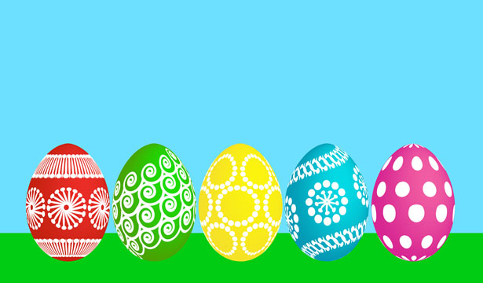  26
27  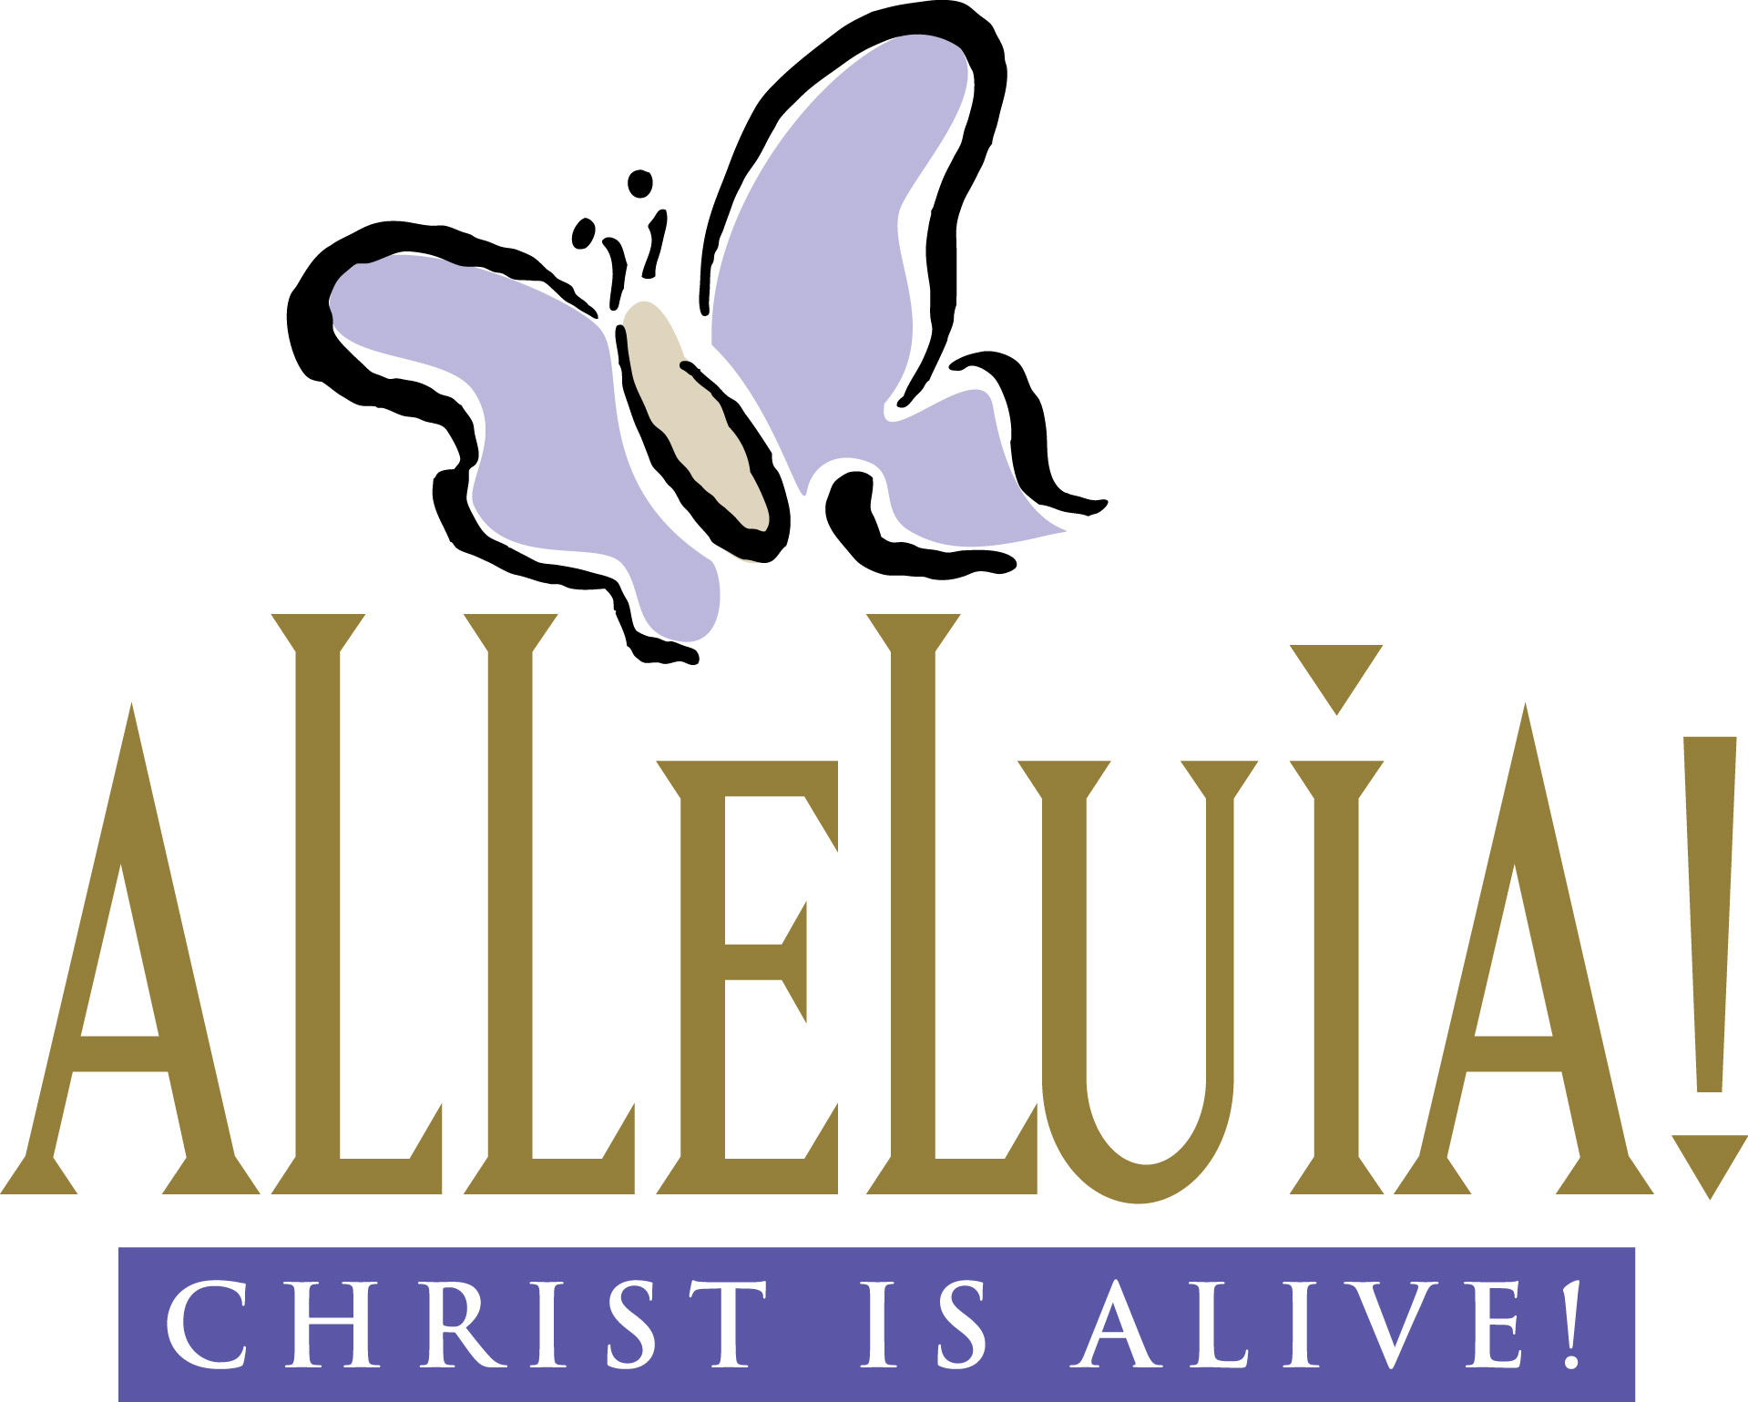 | 28  NO SCHOOL | 29  Breaded Ranch Chicken  Rice Pilaf  Milk Only | 30  Chicken BBQ  Mashed Potatoes  Milk Only | 31  Chocolate Chip Waffles & Sausage  Milk Only | Apr. 1  Pizza  Dessert  Milk Only
SC = Peanut Free
Lunches (includes drink): $3.75 each +$2.25 additional entrée/55¢ Milk Only
*SUBWAY Selections: T = Turkey, H = Ham, I = Italian

