FEBRUARY 2016 LUNCHES St. John Neumann Regional School

Student____________________________________ Grade ____ Print & return with payment $___________ Cash/Check __________

SUNDAY | MONDAY | TUESDAY | WEDNESDAY | THURSDAY | FRIDAY | SATURDAY
 | 1  Subway Mondays*  T H I  Milk Only | 2  Grilled Chicken Cordon Bleu Sand.  Buttered Broccoli  Milk Only | 3 Ham & Green Bean Soup  Sausage & Cheese Sandwich on Roll  Milk Only | 4 (circle one)  Bacon Hamburger  Bacon Cheeseburger  Crispy Crowns  Milk Only | 5  Pizza  Dessert  Milk Only | 6
7 | 8  Subway Mondays*  T H I  Milk Only | 9  Kielbasa  Buttered Noodles  Corn  Milk Only | 10 Open-Faced Hot Turkey Sand.  Sweet Potatoes  Cranberry Sauce  Milk Only | 11  Walking Taco  Green Beans  Milk Only | 12  Pizza  Dessert  Milk Only | 13
  14 | 15 NO SCHOOL  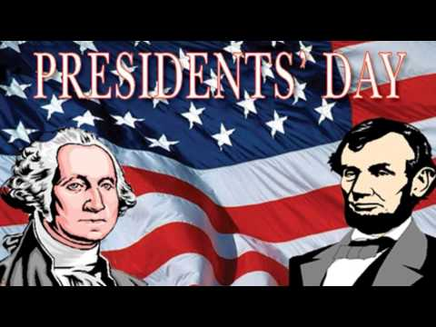 | 16  Meat Sauce w/  Pasta  Mixed Vegetables  Milk Only | 17  Chicken Noodle Soup  Grilled Cheese  Milk Only | 18  Battered Fish  Parsley Potatoes  Milk Only | 19  Pizza  Dessert  Milk Only | 20
21 | 22  Subway Mondays*  T H I  Milk Only | 23 Hamburger/Cheese/  Pizza Sauce in Quesadilla  Corn  Milk Only | 24  Breaded Chicken Sandwich  Corn  Milk Only | 25  Chili Dog  Tater Tots  Milk Only | 26  Pizza  Dessert  Milk Only | 27
28

SC = Peanut Free
Lunches (includes drink): $3.75 each +$2.25 additional entrée/55¢ Milk Only
*SUBWAY Selections: T = Turkey, H = Ham, I = Italian

