DECEMBER 2015 LUNCHES St. John Neumann Regional School

Student____________________________________ Grade ____ Print & return with payment $___________ Cash/Check __________

SUNDAY | MONDAY | TUESDAY | WEDNESDAY | THURSDAY | FRIDAY | SATURDAY
 |  | 1  Walking Taco  Green Beans  Milk Only | 2  Hot Dog  Chicken Bow Tie Soup  Milk Only | 3  Breaded Chicken Sandwich  Tater Tots  Milk Only | 4  Pizza  Dessert  Milk Only | 5
6 | 7  Subway Mondays*  T H I  Milk Only | 8  Grilled Cheese  Corn  Milk Only | 9  NO LUNCH  Early Dismissal | 10  Breaded Fish  French Fries  Milk Only | 11  Pizza  Dessert  Milk Only | 12
13 | 14  Subway Mondays*  T H I  Milk Only | 15  Chicken BBQ  Mashed Potatoes  Milk Only | 16  Corn Dog  Baked Beans  Milk Only | 17  Ham & Cheese Wrap  Carrot Sticks  Milk Only | 18  Pizza  Dessert  Milk Only | 19
20 | 21  Subway Mondays*  T H I  Milk Only | 22  Smoked Sausage  Mac & Cheese  Milk Only | 23 Early Lunch  Baked Ziti  Salad  Roll & Butter  Milk Only | 24  NO SCHOOL | 25  NO SCHOOL  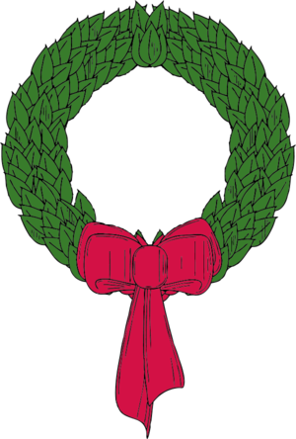 | 26
27 | 28  NO SCHOOL | 29  NO SCHOOL | 30  NO SCHOOL | 31  NO SCHOOL | 1  NO SCHOOL  
SC = Peanut Free
Lunches (includes drink): $3.75 each +$2.25 additional entrée/55¢ Milk Only
*SUBWAY Selections: T = Turkey, H = Ham, I = Italian

